Iteration 5

CIS 320-05

Group A

Michelle Green, Aquazia Hamler, Deven Johnson, Justin Laramore, Noah Leon

**Class Diagram**

Class diagram stands as the “blueprints” of our system. We use the class diagrams to model the objects that make up the system, to display the relationships between the objects, and to describe what those objects do and the services that they provide. Our class diagram clearly maps out the structure of our system by modeling our classes, attributes, operations, and relationships between objects.

[Class Diagram.vsdx](https://cardmaillouisville.sharepoint.com/:u:/s/GroupA/EZnauzLpeSdMmd2NKb2acoUBY0aDZ3npgYoIrzfJinGvUg?e=AUbstr)

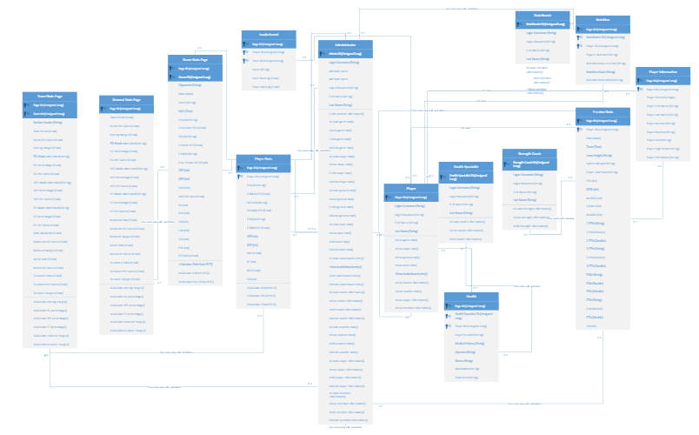

**Database Design**

Our database diagram graphically represents our relational model of a SQL Server database. This diagram helps users identify which tables, columns, and relationships exist between objects, enabling them to efficiently access, query, or modify data. A well-defined database diagram also improves the accuracy of data, as it reduces the chances of incorrect information being entered into the database.

[Database Diagram.vsdx](https://cardmaillouisville.sharepoint.com/:u:/s/GroupA/EaAA13Vz1dZJiNDHBGhvABMBO0tPji55LnSFNcVRzYwmMw?e=E9BfY5)

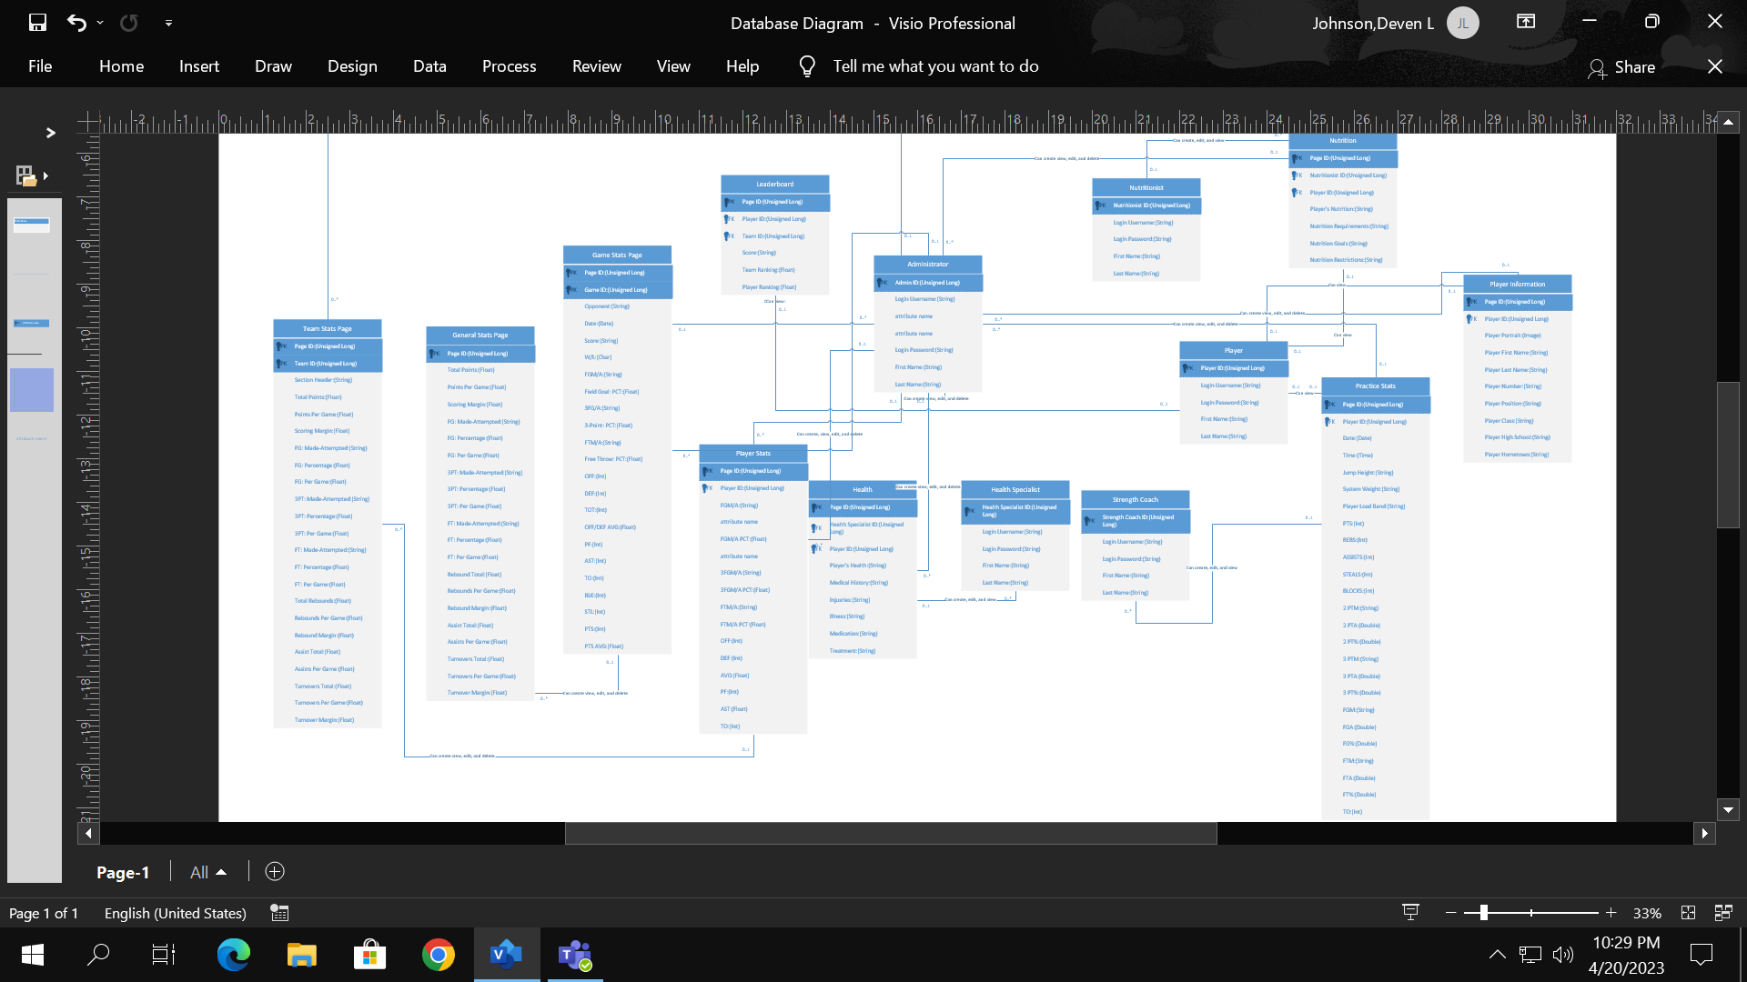

**Database Definitions**

**Edit Website**

|  |  |  |  |  |
| --- | --- | --- | --- | --- |
| Attribute | Attribute Definition | Attribute Type | Attribute Size | Key |
| Page ID | Unique identifier for the page | Unsigned long | 4 bytes | Primary |

**General Stats**

|  |  |  |  |  |
| --- | --- | --- | --- | --- |
| Attribute | Attribute Definition | Attribute Type | Attribute Size | Key |
| Page ID | Unique identifier for the page | Unsigned long | 4 bytes | Primary |
| Total Points | The team's total points | Float | 4 bytes | No |
| Points Per Game | The team's average points per game | Float | 4 bytes | No |
| Scoring Margin | The Teams scoring margin | Float | 4 bytes | No |
| FG: Made-Attempted | Teams field goal made verses attempted | String | 255 bytes max | No |
| FG: Percentage | Teams field goal percentage | Float | 4 bytes | No |
| FG. Per Game | Teams average field goal points per game | Float | 4 bytes | No |
| 3PT: Per Game | Teams three-point shots per game | Float | 4 bytes | No |
| FT: Made-Attempted | Teams free throws made verses attempted | String | 255 bytes | No |
| FT: Percentage | Teams free throw percentage | Float | 4 bytes | No |
| FT: Per Game | Teams average free throws per a game | Float | 4 bytes | No |
| Rebound. Total | Teams total rebounds | Float | 4 bytes | No |
| Rebound. Per Game | Teams average rebounds per game | Float | 4 bytes | No |
| Rebound. Margin | Teams rebound margin | Float | 4 bytes | No |
| Assist. Total | Teams total number of assists | Float | 4 bytes | No |
| Assist. Per Game | Teams average assists per game | Float | 4 bytes | No |
| Turnover. Total | Teams total turnovers | Float | 4 bytes | No |

**Game Stats**

|  |  |  |  |  |
| --- | --- | --- | --- | --- |
| Attribute | Attribute Definition | Attribute Type | Attribute Size | Key |
| Page ID | Unique identifier for the page | Unsigned long | 4 bytes | Primary |
| Game ID | Unique identifier for the game | Unsigned long | 4 bytes | Primary |
| Opponent | The name of the opposing team | String | 255 bytes | No |
| Date | The date of the game | Date | 3 bytes | No |
| Score | Ending game score of both teams | String | 255 bytes | No |
| W/L | Signifying is the team won or lost the game | Char | 1 byte | No |
| FGM/A | The number of field goals made verses attempted | String | 255 bytes | No |
| Field Goal: PCT | Field goal performance percentile | Float | 4 bytes | No |
| 3FG/A | 3-point field goals made verses attempted | String | 255 bytes | No |
| 3-point: PCT | 3-point field goal performance percentile | Float | 4 bytes | No |
| FTM/A | Number of free throws made verses attempted | String | 255 bytes | No |
| Free-throw: PCT | Free throw performance percentile | Float | 4 bytes | No |
| OFF | Specific stats for a player on offense | Integer | 4 bytes | No |
| DEFF | Specific stats for a player on defense | Integer | 4 bytes | No |
| TOT | Specific stat that tells how many teams a player has played for | Integer | 4 bytes | No |
| AVG | Average of player’s stats both on offense and defense | Float | 4 bytes | No |
| PF | Specific stats about a foul a specific player have conducted | Integer | 4 bytes | No |
| AST | Specific stat to a player after helping a teammate score | Integer | 4 bytes | No |
| TO | Specific stat for each player has conducted a turnover | Integer | 4 bytes | No |
| BLK | Specific stat that shows a player blocking another | Integer | 4 bytes | No |
| STL | Specific stat per player for number of steals per player | Integer | 4 bytes | No |
| PTS | Specific stat per player for number of points score | Integer | 4 bytes | No |
| AVG | Average between total points per player | Float | 4 bytes | No |

**Team Stats Page**

|  |  |  |  |  |
| --- | --- | --- | --- | --- |
| Attribute | Attribute Definition | Attribute Type | Attribute Size | Key |
| Page ID | Unique identifier for the page | Unsigned long | 4 bytes | Primary |
| Team ID | Unique Identifier for each team | Unsigned long | 4 bytes | Primary |
| Section Header | A header that separates the stats into related groups. | String | 255 Bytes | No |
| Total Points | The total points scored during the specified timeframe | Unsigned long | 4 bytes | No |
| Points Per Game | Average points per game during the specified timeframe | Unsigned long | 4 bytes | No |
| Scoring Margin | UofL points per game minus the opponents points per game | Double | 8 bytes | No |
| FG: Made-Attempted | The field goals made and attempted respectively, separated by a dash | String | 255 bytes | No |
| FG: Percentage | Field goals made divided by field goals attempted | Double | 8 bytes | No |
| FG: Per Game | Average field goals per game | Double | 8 bytes | No |
| 3PT: Made-Attempted | The three pointers made and attempted respectively, separated by a dash | String | 255 bytes | No |
| 3PT: Percentage | Three pointers made divided by the three pointers attempted | Double | 8 bytes | No |
| 3PT: Per Game | Average three pointers per game | Double | 8 Bytes | No |
| FT: Made-Attempted | The free throws made and attempted respectively, separated by a dash | String | 255 bytes | No |
| FT: Percentage | The free throws made divided by the free throws attempted | Double | 8 bytes | No |
| FT: Per Game | Average free throws per game | Double | 8 bytes | No |
| Total Rebounds | The total number of rebounds | Unsigned long | 4 bytes | No |
| Rebounds Per Game | The average rebounds per game | Double | 8 bytes | No |
| Rebound Margin | UofL rebounds per game minus the opponent’s rebounds per game | Double | 8 bytes | No |
| Total Assists | The total number of assists | Unsigned long | 4 bytes | No |
| Assists Per Game | The average number of assists | Double | 8 bytes | No |
| Total Turnovers | The total number of turnovers | Unsigned long | 4 bytes | No |
| Turnovers Per Game | The average turnovers per game | Double | 8 bytes | No |
| Turnover Margin | UofL turnovers per game minus the opponent's turnovers per game | Double | 8 bytes | No |

**Leaderboard**

|  |  |  |  |  |
| --- | --- | --- | --- | --- |
| Attribute | Attribute Definition | Attribute Type | Attribute Size | Key |
| Page ID | Unique identifier for the page | Unsigned long | 4 bytes | Primary |
| Player ID | Unique identifier for each player | Unsigned long | 4 bytes | Foreign |
| Team ID | Unique identifier for each team | Unsigned long | 4 bytes | Foreign |
| Score | Ending game score of both teams | String | 255 bytes | No |
| Team Ranking | Each team’s rank based off current team's record | Float | 4 bytes | No |
| Player Ranking | Each player’s rank based off player’s stats | Float | 4 bytes | No |

**Nutrition**

|  |  |  |  |  |
| --- | --- | --- | --- | --- |
| Attribute | Attribute Definition | Attribute Type | Attribute Size | Key |
| Page ID | Unique identifier for the page | Unsigned long | 4 bytes | Primary |
| Nutritionist ID | Unique identifier for Nutritionist | Unsigned long | 4 bytes | Foreign |
| Player ID | Unique identifier for each player | Unsigned long | 4 bytes | Foreign |
| Players Nutrition | Each players current nutrition | String | 255 bytes | No |
| Nutrition Requirements | Specific minimum requirements for nutrition provided to each player | String | 255 bytes | No |
| Nutrition Goals | Specific goals set for each player for nutrition | String | 255 bytes | No |
| Nutrition Restrictions | Specific restrictions for each player in nutrition | String | 255 bytes | No |

**Health**

|  |  |  |  |  |
| --- | --- | --- | --- | --- |
| Attribute | Attribute Definition | Attribute Type | Attribute Size | Key |
| Page ID | Unique identifier for the page | Unsigned long | 4 bytes | Primary |
| Health Specialist ID | Unique identifier for Health specialist | Unsigned long | 4 bytes | Foreign |
| Player ID | Unique identifier for each player | Unsigned long | 4 bytes | Foreign |
| Players Health | Each players current health status | String | 255 bytes | No |
| Medical History | Each players medical history | String | 255 bytes | No |
| Injuries | Each players information for injuries | String | 255 bytes | No |
| Illness | Each player information for any illness | String | 255 bytes | No |
| Medication | Medications player are currently using | String | 255 bytes | No |
| Treatment | Documentation of treatment plan | String | 255 bytes | No |

**Practice**

|  |  |  |  |  |
| --- | --- | --- | --- | --- |
| Attribute | Attribute Definition | Attribute Type | Attribute Size | Key |
| Page ID | Unique identifier for the page | Unsigned long | 4 bytes | Primary |
| Player ID | Unique identifier for each player | Unsigned long | 4 bytes | Foreign |
| Date | Practice Date | Date | 3 bytes | No |
| Time | Practice Time | Time | 3 bytes | No |
| Jump Height | Jump height in mm calculated | String | 255 bytes | No |
| System Weight | Data from Force Plate system | String | 255 bytes | No |
| Player Load Band | Data from Catapult system | String | 255 bytes | No |
| PTS | Points from practice game box | Integer | 4 bytes | No |
| REBS | Rebounds from practice game box | Integer | 4 bytes | No |
| ASSISTS | Assists from practice game box. | Integer | 4 bytes | No |
| STEALS | Steals from practice game box. | Integer | 4 bytes | No |
| BLOCKS | Blocks from practice game box | Integer | 4 bytes | No |
| 2 PTM | 2 Point shots made from practice game box. | String | 255 bytes | No |
| 2 PTA | 2 Point shots attempted from practice game box. | Double | 8 bytes | No |
| 2 PT% | Average 2-point shots from practice game box | Double | 8 Bytes | No |
| 3 PTM | 3 Point shots made from practice game box | String | 255 bytes | No |
| 3 PTA | 3 Point shots attempted from practice game box. | Double | 8 bytes | No |
| 3 PT% | Average 3-point shots from practice game box | Double | 8 Bytes | No |
| FGM | Field goals made from practice game box | String | 255 bytes | No |
| FGA | Field goals attempted from practice game box. | Double | 8 bytes | No |
| FG% | Average field goals from practice game box | Double | 8 Bytes | No |
| FTM | Free throws made from practice game box | String | 255 bytes | No |
| FTA | Free throws attempted from practice game box. | Double | 8 bytes | No |
| FT % | Average free throws from practice game box | Double | 8 Bytes | No |
| TO | Turnovers from practice game box | Integer | 4 bytes | No |

**Player Information**

|  |  |  |  |  |
| --- | --- | --- | --- | --- |
| Attribute | Attribute Definition | Attribute Type | Attribute Size | Key |
| Page ID | Unique identifier for the page | Unsigned long | 4 bytes | Primary |
| Player ID | Unique identifier for each player | Unsigned long | 4 bytes | Foreign |
| Player Portrait | A picture of the player | Image |  | No |
| Player First Name | Players first name | String | 255 bytes | No |
| Player Last Name | Players last name | String | 255 bytes | No |
| Player Number | Player jersey number | String | 255 bytes | No |
| Player Position | Player position | String | 255 bytes | No |
| Player Class | Player’s current class | String | 255 bytes | No |
| Player High school | Players’ high school | String | 255 bytes | No |
| Player Hometown | Players’ hometown | String | 255 bytes | No |

**Player Statistics**

|  |  |  |  |  |
| --- | --- | --- | --- | --- |
| Attribute | Attribute Definition | Attribute Type | Attribute Size | Key |
| Page ID | Unique identifier for the page | Unsigned long | 4 bytes | Primary |
| Player ID | Unique identifier for each player | Unsigned long | 4 bytes | Foreign |
| FGM/A | The number of field goals made verses attempted | String | 255 bytes | No |
| FGM/A PCT | Field goal performance percentile | Float | 4 bytes | No |
| 3FGM/A | 3-point field goals made verses attempted | String | 255 bytes | No |
| 3FGM/A PCT | 3-point field goal performance percentile | Float | 4 bytes | No |
| FTM/A | Number of free throws made verses attempted | String | 255 bytes | No |
| FTM/A PCT | Free throw performance percentile | Float | 4 bytes | No |
| OFF | Points produced by player  possessions | Integer | 4 bytes | No |
| DEF | Points defended against | Integer | 4 bytes | No |
| AVG | Average points within game | Float | 4 bytes | No |
| PF | Personal fouls received | Integer | 4 bytes | No |
| AST | Amount of total contribution to teams score | Float | 4 bytes | No |
| TO | Number of turnovers during session | Integer | 4 bytes | No |

**User Interface Navigation Diagram and Screen Layout**

The User Interface Navigation Diagram will show basic layout of the system that interact for reaching different parts of the website. It will depict how user input is used with buttons, forms, and other objects to browse the website, store data, and view it.

**Sign in Page**

When accessing website, the first page will require login credentials to access any data. Sign in button will redirect the user to the dashboard if correct credentials are entered.

**Dashboard**

After signing in, Users will be able to select one of the three categories, Player Health, Player Statistics and Team administration. Selecting any of these icons will redirect user to the respected screen.

**Player Statistics Dashboard**

Player Statistics displays all active team members with their position, class, height, and weight. Selecting an Icon for a player will bring the user to the player statistics page for them.

**Player Statistics**

Player Statistics will allow users to select, edit or remove practice records, performance records, DARI, Force and Perch information onto a user account. Records will be held in table format to keep uniform presentation unless specified otherwise.

**Player Health Dashboard**

The player health dashboard mirrors the player statistics dashboard within the same layout. It displays the position, class, height, and weight of players.

**Player Health**

The player health dashboard will allow medical documents and nutritional data to be added within the players profile. Selecting the plus icon will allow a new column to be added to the user field and select the trash icon will delete the records.

**Team Administration**

The Team administration page will show four categories: Report Maintenance, Player Maintenance, User Maintenance, and Team Maintenance. Selecting these icons will redirect to the respective table to edit and make changes to database of users, players, or reports.

**Use Interface Prototypes**

**Use Case 2:** Create General Stats, **Use Case 3:** Edit General Stats, **Use Case 4:** Delete General Stats.

**Use Case 5:** Edit Game Stats, **Use Case 6:** Create Game Info, **Use Case 7:** Edit Game Info, **Use Case 8:** Review Game Info, **Use Case 9:** Delete Game Info.

**Use Case 10:** Edit Player Information, **Use Case 11:** Create Player Profile, **Use Case 12:** Edit Player Profile, **Use Case 13:** Delete Player Profile.

**Use Case 14:** Create Player Stats, **Use Case 15:** Edit Player Stats, **Use Case 16:** Delete Player Stats.

**Use Case 17:** Upload Player Portrait, **Use Case 18:** Remove Player Portrait.

**Use Case 19:** Edit Team Info, **Use Case 20:** Create Team Stats, **Use Case 21:** Edit Team Stats, **Use Case 22:** Delete Team Stats.

**Use Case 23:** Edit Leaderboards, **Use Case 24:** View Leaderboards.

**Use Case 25:** Create Nutrition Info, Use **Case 26:** Create Players Nutrition, **Use Case 27:** Edit Players Nutrition, **Use Case 28:** Remove Players Nutrition, **Use Case 29:** Input Nutrition Issues, Use **Case 30:** Remove Nutrition Issues.

**Use Case 31:** Create Health Info, **Use Case 32:** Edit Health Info

**Use Case 33:** Upload Medical Records, Use **Case 34:** Update Medical Records, Use **Case 35:** Remove Medical Records.

**Use Case 36:** Upload Practice Info, Use **Case 37:** Update Practice Info, **Use Case 38:** Review Practice Info, **Use Case 39:** Remove Practice Info.

**Gantt Chart**

A Gantt Chart displays the task for I5 and who they are assigned to. Within the chart are the details for each task such as durations, start date, end date, and dependencies. This is helpful for the team to understand what they need to do and what everyone else is doing. It helps the group to stay on track and in one accord.

[Link to Gantt Chart](https://cardmaillouisville.sharepoint.com/:x:/s/GroupA/EdGdEnD4E41Eiqrh1l74gm0BoJ90XB2JTe0WjIiV_-PXpQ?e=VlvakD)

